ZARZĄDZANIE MEDIAMI
Volume xxx , p. xxx-xxx
doi: xxxxxxxxxxxxxxx
www.ejournals.eu/ZM
Author Name 1
Affiliation: Department One, Institution One
ORCID

Author Name 2
Affiliation: Department Two, Institution Two, City Two, Country Two
ORCID

Information about author 1: brief profile concerning author 1.
Information about author 2: brief profile concerning author 2.
Article title
(style „Title” Times New Roman 14 font size, bold, centered text)
ABSTRACT
The abstract should have up to 200 words. It should summarize the content of the article. Information on the subject of the study, the purpose of the study, the cognitive gap, research methods used and data collection techniques and results should be included within. The specifics of the research problem should be indicated. The abstract cannot be the same as the introduction to the article. It should not contain opinions, quotes or digressions loosely related to the subject of the text.

Key words: a maximum of 5 keywords should be indicated

JEL:

Introduction (headline: Times New Roman 13 font size, align text to the left)
In the journal Zarządzanie Mediami [English version: Media Management] we publish the following types of articles in accordance with the Polish Scientific Bibliography classification:
- original scientific article
- review article
- case study
- legal commentary
- scientific review
- conference report.

In order to submit an article for publication, the Author should send a text to the email address of editorial staff. The addresses can be found at: http://www.ejournals.eu/ZM/menu/361/. The text should be formatted according to the guidelines contained in this template. It should be divided into sections (preferably the so-called IMRAD structure: Introduction - Methods - Results - Discussion). The introductory part should outline the context, formulate the research problem, the aims of the article, possibly hypotheses or research questions. The cognitive gap which justifies undertaking research in a given area should be indicated. Additionally, the research perspective used or the theoretical framework of the research can be described.

The proper text of the article (without the title page and bibliography) should not exceed 12 pages. All types of acronyms should be clarified the first time they are used. Do not use bold, underline, spaced-out font or italics in the text. The latter is acceptable for foreign language concepts, titles, short quotes.

Theoretical background (second order headline Times New Roman 12 font size)
This part should review the literature on the subject. If the theoretical framework was not presented in the introduction, this can be done in this section. When providing sources, APA style rules should be applied. Next to the author's name, which we cite in round brackets, we give the year of publication and the cited page. If the surname does not appear directly in the text, they should be given in brackets (surnames are given without names and initials) (Nowak, 2003, p. 10).

Quotes longer than 40 words should be written according to a defined style ("quote" Times New Roman 11 font size, indent from the left 2.5 cm, indent from the right
0 cm, single line spacing). Shorter quotes should be marked in italics. Each quote requires an appropriate source, including the page (Kowalski, 2011, p. 32).

Methodology
In this section, the Author should describe in detail what the subject of the study was, what methods and research techniques were used, when the study was carried out, how it was done, etc.

Materials and reasearch results
In this part, the Author should describe the results obtained. All graphic materials, data visualizations, tables, charts, drawings, etc. must be an integral part of the argument, should be indicated in the text and numbered. To this end, it should be indicated which table / graph / drawing refers to the discussed issue.
Tabela 1. Table title
Source:
Charts entered into the text should be in an editable version (have a file in Excel that will allow them to be redrawn while maintaining the correct figures).
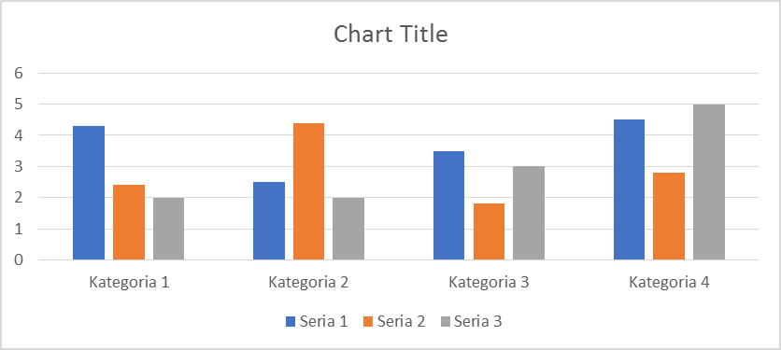
Source:

Third-order headings (Times New Roman, 12 font size)

Discussion of results
This part should discuss the research results referring to the up-to-date achievements in the studied area.

Conclusions and summary
In this section the most important conclusions from the research should be presented, along with article’s summary and necessary comments. Here the authors can form their own opinions and observations regarding the results of the research.

Bibliography:
Description of the monograph:
Author's last name, first initial. (Publication date). Book title. City of publication: Publishing company.
Examples:
Boorstin, D. (1992). The creators: A history of the heroes of the imagination, New York: Random House.
Kowalski, T., Jung B. (2008). Media na rynku: wprowadzenie do ekonomiki mediów. Warsaw: Wydawnictwa Akademickie i Profesjonalne.
Nierenberg, B. (2011). Zarządzanie mediami, ujęcie systemowe, Krakow: Wydawnictwo Uniwersytetu Jagiellońskiego.

Description of the edited work:

Author's last name, first initial. (eds.). (Publication date). Book title. City of publication: Publishing company.
Examples:

Jolling, T., Bridgestone T., (eds.). (1998). Antidotes to Catastrophe. Sydney:
Cape.
Zorska, A. Molęda-Zdziech, M. Jung B. (eds.). (2014). Kreatywność i innowacyjność w erze cyfrowej. Warszawa: Oficyna Wydawnicza Szkoła Główna Handlowa.

Book with multiple authors:

Author's last name, first initial. (Publication date). Article title. In: First initial. Last name (eds.) Book with multiple authors title (p.). City of publication: Publishing company.

Article in a journal:
Author's last name, first initial. (Publication date). Article title. Periodical title, volume number (issue number if available), inclusive pages.

Online journals (the bibliographic description of each item must contain the DOI identifier, which should be included at the end of the publication address):

Author's last name, first initial. (Publication date). Article title. Periodical title, volume number (issue number if available), inclusive pages. doi 11.1037/02X8-6133.24.2.225 (if doi is not available address URL should be submitted).

Online documents:
Author's last name, first initial. (Publication date). Article title. Retrieved from: full URL (Accessed date).
_________________________________________________________________________

Other comments from the editorial board
- Articles are subject to internal review, in which members of the Editorial Board and the Scientific Council of the magazine participate. Authors may be asked to make changes before sending the text for external review.
- Please apply any changes to the so-called "Tracking mode." This allows you to speed editorial work up.

Change tracking mode
In text editors we have the ability to track changes made by individual authors. In MS Office Word, we can use this mode as shown in Figure 1:
Picture 1 MS Office Word tracking mode
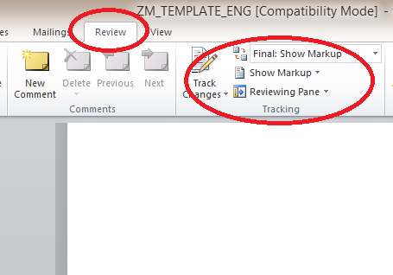
- Please do not use formatting that prevents breaking text (so-called hard line breaks, soft line breaks, etc.).
- In order to anonymize your data while working in the review mode, select the "File" tab, then the "Options" function and make changes in the general settings regarding the username:
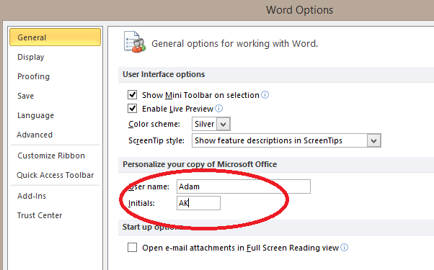

More information regarding JEL codes can be found: http://www.ejournals.eu/aktualnosci/48/Klasyfikacje-w-publikacjach-naukowych/
Footnotes are comments related to the content of the article. When providing sources, APA style rules should be applied.
Individual subtitles should have proper names, they do not have to be formulated as in this template.

